LISA KOCH (singer-songwriter-comedian-actor-raconteur, pronounced Coke)
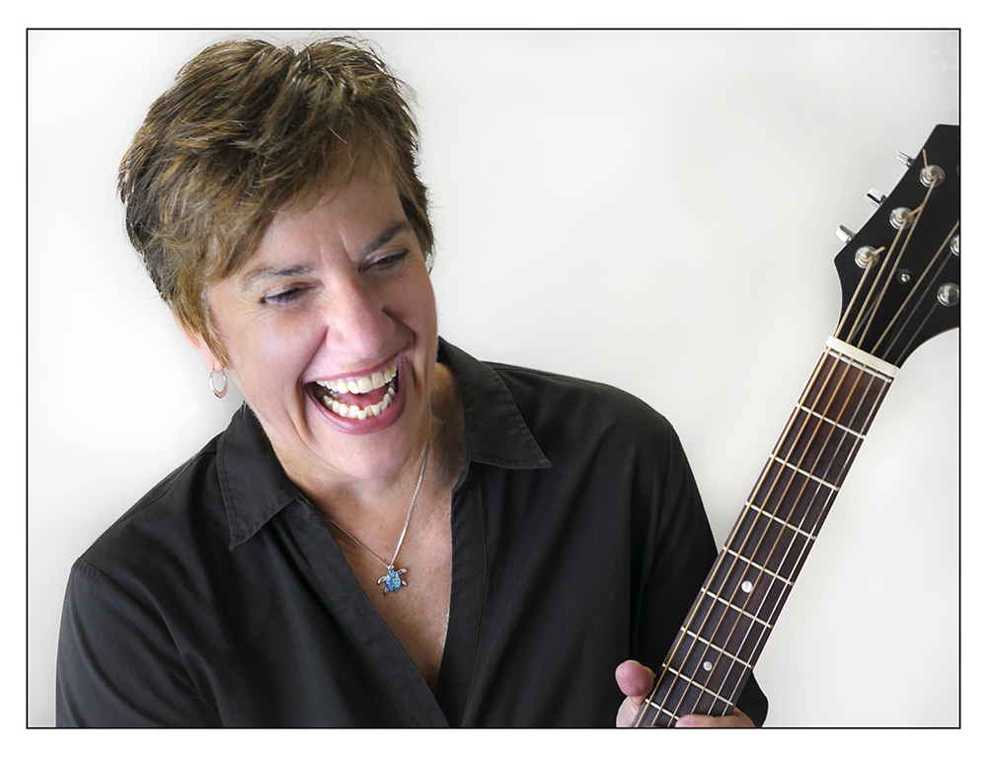
Imagine Tina Fey meets Randy Rainbow with Joan Jett guitar chops... and you’ve got singer-comedian Lisa Koch.

Twisted songs, social satire, and singing vulvas. Lisa brings the funny, with velvet pipes and razor-sharp parody. With 5 solo recordings, she is an alumnus of Seattle’s loony sketch comedy duo, Dos Fallopia (My Breasts are Out of Control), and cult quartet Venus Envy (I'll Be A Homo for Xmas). She has shared the stage with Steve Martin, Janis Ian, Lily Tomlin, Karla Bonoff, Kate Clinton, and more. Lisa has co-written such warped shows as "The Carpeters: Uncomfortably Close To You," “Two’s Company, I’m a Crowd,” and “Ham for the Holidays: The Hamchurian Candidate.” Koch has been featured on Olivia and LOGO, is the composer of Off-Broadway musical “27, Rue de Fleurus”, and is proud to report that one of her songs has actually been sampled by Jay-Z. Lisa brings to the stage her wacky songs, her alter ego Sister Mary Agnes, and her musings on being a woman… from middle age to mammograms to mirth.

“Be prepared to have your hair blown back by the musical comedy force that is Lisa Koch.”
-- LN Magazine

“Hearing Seattle’s Lisa Koch is one of life’s wickedest pleasures… her brand of absurd confessional comedy is clearly resonating with millions of fans.” -- Curve Magazine

“Koch’s talents seem to know no bounds as she goes from gut-busting comedy into an introspective beautiful medley and back again…” -- Broadway World

“None of this would work so well if Koch weren't such a dandy singer, guitarist and song-dismantler. There's almost nothing she can't do to subvert a popular classic…” -- Seattle Times

Video links
https://vimeo.com/211171374 Midlife Medley (comedy)
https://youtu.be/Ijhuf6EKSvI Enjoy the Ride (acoustic)
https://youtu.be/UAdQzI9eVu0 The Waiting Womb (sketch comedy)
https://youtu.be/3tMyNhTAFoU I’m a Middle-Aged Woman (comedy)
https://youtu.be/Guyx3ju1PHE Peace Medley (acoustic)

Tongueinchic Productions • www.heylisa.com • lisa@heylisa.com • 206-276-2272
Twitter: @heylisakoch • FB: heylisakoch, lisakochseattle • Instagram: @heylisak

